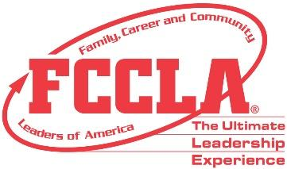
PROCLAMATION
FCCLA WEEK
FEBRUARY 12-16, 2024

WHEREAS,
Family, Career and Community Leaders of America (FCCLA), the national nonprofit, family-focused, intracurricular student organization for Family and Consumer Sciences students through grade 12, helps youth assume their roles in society through Family and Consumer Sciences education in the areas of personal growth, family life, college readiness, career exploration, leadership, and community involvement; and
WHEREAS,
The organization extends classroom learning through chapter service projects that develop leadership and employability skills and helps young men and women learn how to plan, make decisions, carry out program evaluations, and take action through working with other youth and adults within their school, community, and state; and
WHEREAS,
FCCLA offers members an opportunity to work together for everyday purposes for the improvement of themselves, as well as their families, careers, and communities, and
WHEREAS,
The week of February 12 through 16, 2024, has been designated national FCCLA Week.
NOW, THEREFORE,
I, (insert name of elected official), hereby proclaim the week beginning February 12, 2024, as national FCCLA Week in (insert your community/state) and urge all citizens to acquaint themselves with the activities and values of Family, Career and Community Leaders of America, to show interest in, and provide support and encouragement to the students who are working to achieve knowledge and experience that will help prepare them for future responsibilities as active and concerned adult members of society.

___________________________ ___________________ _________________
Signature Title Date

